**ACKNOWLEDGMENT**

My group members and I have taken lot of efforts to make this project. However, it would not have been possible without the kind support and help of our project guide. I would like to extend my sincere thanks to all of them.

I am highly indebted to Dr. (prof) L.K. Bandhopadhyay (former Head of the Department, ECE) who is also our project guide, for his guidance and constant supervision in completing the project. At last I would also thank my group, my team members for constant support and efficient team work which made the final year project to be a successful one. The role played by each and every members of group were excellent. Co-operation, hard work and team management leads to a successful outcome.

**ABSTRACTS**

The Anti–Collision device is a detection device meant to be incorporated into cars for the purpose of safety. As opposed to the anti–collision devices present in the market today, this system is not designed to control the vehicle. Instead, it serves as an alert in the face of imminent collision. The device is intended to find a way to implement a minimum spacing for cars in traffic in an affordable way. It would also achieve safety for the passengers of a moving car. The device is made up of an infrared transmitter and receiver. Also incorporated into it is an audio visual alarm to work in with the receiver and effectively alert the driver and/or the passengers. The device would still sound an alarm even though it is not receiving infrared beams from the oncoming vehicle. This is due to reflection of its own infrared beams. At the end of the design and testing process, overall system was implemented with a constructed work, tested working and perfectly functional. The system which is the design and construction of an anti-collision system for vehicles was designed considering some factors such as economy, availability of components and research materials, efficiency, compatibility, portability and also durability. The performance of the system after test met design specifications.

**INTRODUCTION**

The application consists of three main modules:

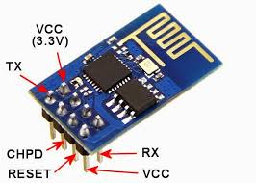 /////////////////////////////////////////////////////////////////////////////

1. ATMEGA328P microcontroller
2. 3-Axis ACCELEROMETER
3. Wi-Fi 802.11-b/g/n

Each of the modules consists of several processes which provide various functionalities.

Safety is a necessary part of man’s life. Due to the accident cases reported daily on the major roads in all parts of the developed and developing countries, more attention is needed for research in the designing an efficient car driving aiding system. It is expected that if such a device is designed and incorporated into our cars as a road safety device, it will reduce the incidence of accidents on our roads and various premises, with subsequent reduction in loss of life and property.

However, a major area of concern of an engineer should be safety, as it concerns the use of his/her inventions and the accompanying dangers due to human limitations. When it comes to the use of a motor vehicle, accidents that have occurred over the years tell us that something needs to be done about them from an engineering point of view. According to the 2007 edition of the Small-M report on the road accident statistic in Malaysia, a total of 6,035 people were killed in 2000 and the fatality spring up to 6,287 in 2006 from accident cases reported in 250,429 and 341,252 cases of accident for 2000 and 2006 respectively. In India according to 2016 data analysis, at every 60 sec there were 26 people loss their life in accidents. Suffice to say that the implementation of certain highway safety means such as speed restrictions, among others, has done a lot in reducing the rates of these accidents. The issue here is that policies of safe driving alone would not eradicate this, the engineer has a role to play, after all the main issue is an engineering product (the motor vehicle). Many motorists have had to travel through areas with little light under much fatigue, yet compelled to undertake the journey out of necessity. It is not always irresponsible to do this. A lot of cases reported is as a result of drivers sleeping off while driving, and when he/she eventually woke up, a head-on collision might have taken place. Not many have had the fortune to quickly avert this.

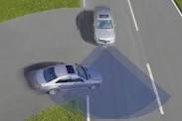

///////////////////////////////////////////////////////////////////////////////////////////////////

**OBJECTIVE OF PROJECT**

Safety is a necessary part of every living body’s life. Due to the accident cases reported daily on the major roads in all parts of the developed and developing countries, more attention is needed for research in the designing an efficient vehicle driving aiding system. It is expected that if such a device is designed and incorporated into our vehicle as a road safety device, it will reduce the incidence of accidents on our roads and various premises, with subsequent reduction in loss of life and property. A lot of cases reported is as a result of drivers sleeping off while driving, and when he/she eventually woke up, a head-on collision might have taken place. It is therefore important to consider the advantages of an early warning system where the driver is alerted of a possible collision with some considerable amount of time before it occurs.

**JUSTIFICATION OF PROJECT: -**

In our project, we are going to make a system as described below: -

* Using A-GPS we can get current location of vehicle, living body or devices.
* According to the dimension of object our system will create a protective virtual wall.
* In our system, every device will be programmed to give them artificial intelligence.
* In our project, every device will have intelligent feature to communicate with each other to get information of moving or static vehicle/devices.
* Our project can prevent collision between vehicle, human body and vehicle etc.
* This project can be installed easily.

**METHODOLOGY**

1. A-GPS will track the location of devices in every second, and will send data to microcontroller.
2. Using that A-GPS microcontroller will be programmed to useful data like speed of moving vehicle, direction of motion, Distance etc.
3. A microcontroller will be programmed to create protective virtual boundary.
4. A microcontroller will try to communicate with another microcontroller using peer to peer multipoint connection to get data of another microcontroller/devices.
5. This connection will be established by using Wi-Fi local host communication.
6. Since connection is peer to peer and multipoint so the range of system will increase n-times.
7. Using this data every device/vehicle will try to prevent that virtual boundary from collision, and hence no one will collide.

**ADOPTED, SYSTEM IMPLEMENTATION & DETAILS**

**OF**

**HARDWARE & SOFTWARE USED**

HARDWARE USED:

SOFTWARE USED:

1. Arduino IDE.
2. Docklight Serial monitor.

**UART COOMUNICATION WITH WIFI ESP**

The universal asynchronous receiver/transmitter (UART) takes bytes of data and transmits the individual bits in a sequential fashion. At the destination, a second UART re-assembles the bits into complete bytes. Each UART contains a shift register which is the fundamental method of conversion between serial and parallel forms. Serial transmission of digital information (bits) through a single wire or other medium is less costly than parallel transmission through multiple wires. UARTs are commonly used in conjunction with communication standards such as TIA. UART is usually an individual (or part of an) integrated circuit (IC) used for serial communication over a computer or peripheral device serial port. UARTs are now commonly included in microcontrollers. A dual UART, or *DUART*, combines two UARTs into a single chip.

The ESP8266 is a low cost Serial-to-Wi-Fi module that interfaces nicely to any microcontroller. However, a word of caution -- it is highly undocumented (primary reason for writing this document), and more importantly, it is frequently updated and not backward compatible. A good example is how newer versions use 9600 baud rate, while older versions (by old I'm referring to 2-3 months old modules) used 57600-115200 baud rates.

**Usage**

First, it is important to understand how the board works. The ESP8266 has a full TCP/UDP stack support. It can also be easily configured as a web server. The module accepts commands via a simple serial interface. It then responds back with the operation's outcome (assuming everything is running correctly). Also, once the device is connected and is set to accept connections, it will send unsolicited messages whenever a new connection or a new request is issued.

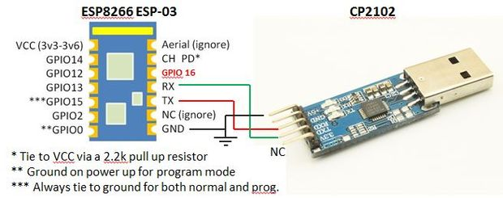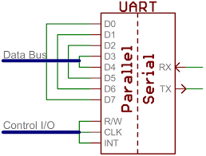

**WIFI AT COMMUNICATION**

Wi-Fi AT command ESP8266 offers a complete and self-contained Wi-Fi networking solution, allowing it to either host the application or to offload all Wi-Fi networking functions from another application processor. When ESP8266 hosts the application, and when it is the only application processor in the device, it is able to boot up directly from an external flash. It has integrated cache to improve the performance of the system in such applications, and to minimize the memory requirements. Alternately, serving as a Wi-Fi adapter, wireless internet access can be added to any microcontroller-based design with simple connectivity through UART interface or the CPU AHB bridge interface.ESP8266 on-board processing and storage capabilities allow it to be integrated with the sensors and other application specific devices through its GPIOs with minimal development up-front and minimal loading during runtime. With its high degree of on-chip integration, which includes the antenna switch, power management converters, it requires minimal external circuitry, and the entire solution, including front-end module, is designed to occupy minimal PCB area.

Sophisticated system-level features include fast sleep/wake context switching for energy-efficient VoIP, adaptive radio biasing for low-power operation, advance signal processing, and spur cancellation and radio co-existence features for common cellular, Bluetooth, DDR, LVDS, LCD interference mitigation. A really cheap and easy way to connect any small microcontroller platform (for example Arduino) wirelessly to Internet. The ESP8266 is now one of the leading platforms for the Internet of Things. It’s super cheap, and super easy to work with. This is a serial module with a built-in TCP/IP stack, so you can use it standalone. We can use AT commands to connect with Wi-Fi networks and open TCP connections without need to have TCP/IP stack running in your own microcontroller: You can simply connect any microcontroller to ESP module and start pushing data up to internet.

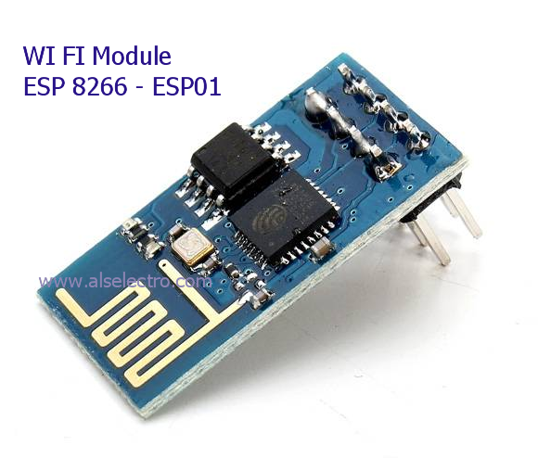

FUNCTION AT COMMAND RESPONSE

Working AT OK

Restart AT+RST OK

Firmware version AT+GMR AT+GMR 0018000902 OK

WiFi Mode AT+CWMODE Query STA AP

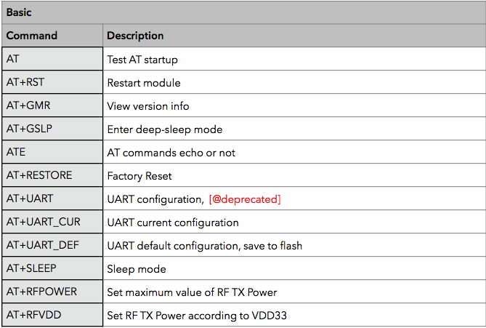

**WIFI P2P (PEER TO PEER) COMMUNICATION**

Wi-Fi peer-to-peer (P2P) allows Android 4.0 (API level 14) or later devices with the appropriate hardware to connect directly to each other via Wi-Fi without an intermediate access point (Android's Wi-Fi P2P framework complies with the Wi-Fi Alliance's Wi-Fi Direct™ certification program). Using these APIs, you can discover and connect to other devices when each device supports Wi-Fi P2P, then communicate over a speedy connection across distances much longer than a Bluetooth connection. This is useful for applications that share data among users, such as a multiplayer game or a photo sharing application.

The Wi-Fi P2P APIs consist of the following main parts:

* Methods that allow you to discover, request, and connect to peers are defined in the Wi-Fi P2P class.
* Listeners that allow you to be notified of the success or failure of Wi-Fi P2P method calls. When calling Wi-Fi P2P methods, each method can receive a specific listener passed in as a parameter.
* Intents that notify you of specific events detected by the Wi-Fi P2P framework, such as a dropped connection or a newly discovered peer.

Wi-Fi Direct negotiates the link with a system that assigns each device a limited wireless access point. The "pairing" of Wi-Fi Direct devices can be set up to require the proximity of a near field communication signal, or a button press on one or all the devices.

**I2C COMMUNICATION WITH ACCELEROMETER**

**LOGIC CONVERTER CIRCUIT**

**COST ANALYSIS**

**FUTURE SCOPE**

1. Driver's safety warning system
2. Deceleration indicating system
3. Vehicle longitudinal control and collision avoidance system for an automated highway system
4. Method, apparatus and system for transmitting and receiving data in a moving linear chain
5. Deceleration magnitude detecting and signalling device
6. Method and apparatus for automatic vehicle event detection, characterization and reporting
7. Process and device for indicating braking power or delay in cars
8. Motor vehicle early warning system
9. Panic stop, deceleration warning system
10. Vehicle collision warning system
11. Automatic following travel system
12. Obstruction detection method for vehicle
13. Inter vehicle communication system
14. Systems and methods for insurance based on monitored characteristics of an autonomous drive mode selection system

**CONCLUSION**

The system which is the design and construction of an anti-collision system for vehicles was designed considering some factors such as economy, availability of components and research materials, efficiency, compatibility, portability and also durability. The performance of the system after test met design specifications. The general operation of the system and performance is dependent on the presence of two moving cars as they get closer to each other. However, it should be stated here that the system was aimed at fabricating prototype, a replica of the actual thing. It is economically viable to undertake certain system this way since testing would not cost so much. Any desire to implement this design into a vehicle would require a laser detector. The problem of power supply would not arise due to the amount of battery power from the car battery. Also the operation of the system is dependent on how well the soldering is done, and the positioning of the components on the Vero board. The Wi-Fi P2P were make away from the power supply stage to prevent heat radiation which, might occur and affect the performance of the entire system. The construction was done in such a way that it makes maintenance and repairs an easy task and affordable for the user should there be any system breakdown. All components were soldered on one Vero-board which makes troubleshooting easier. In general, the system was designed, and the real time implementation done with a photo-type of the model. It leads to decreasing of accident rate.

**REFRENCES**

1. Zungeru, A. M. et al., (2012). Design and Implementation of a Low Cost Digital Bus Passenger Counter. Innovative Systems Design and Engineering,
2. Zungeru, A. M. et al., (2012). Design and Implementation of a Short Message Service Based Remote Controller. Computer Engineering and Intelligent systems,
3. Theraja, B.L., & Theraja, A.K. (1999). A textbook of electrical technology, S. Chand and company, New delhi, India.
4. Electronics, (2012). How stuffs work: How LIDAR Work. Online available at: http://electronics.howstuffworks.com/lidar.htm